**Work Zone Safety social media messages – general driving public**

**Campaign focus:** May 12 - August 31, 2025

Below is written content that can be used for your social media posts. If you are changing or adding to any of the messages here, please always include the hashtag #ConeZoneBC so that we can track social media activity and engagement.

Images to accompany the posts can be found in the “[Campaign resources](https://roadsafetyatwork.ca/work-zone-safety/campaign-resources-2/)” section of the Work Zone Safety section of our website, or feel free to use your own. Images are sized for Facebook, Instagram, and X. For LinkedIn, we recommend using the images that are sized for Facebook. The images can also be used on your website, in your newsletters, etc. Cone

Alliance members are requested to help support the campaign during its focus of May 12 – August 31, but because roadside work happens year-round, members are encouraged to post cone zone messages throughout the year.

If you have any questions or need support with the social media promotion of the campaign, please contact [mbentley@roadsafetyatwork.ca](mailto:mbentley@roadsafetyatwork.ca)

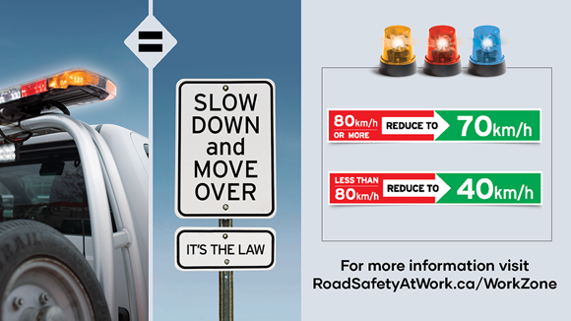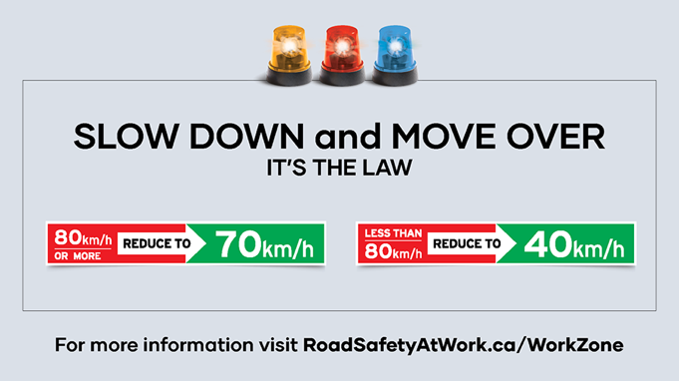

If you see flashing yellow, red or blue, what do you do? Always slow down and move over for these vehicles stopped roadside. These flashing lights mean people are also working roadside. <https://roadsafetyatwork.ca/work-zone-safety/for-drivers/#work-zone-driving-laws>

#ConeZoneBC

Flashing lights, whether yellow, red or blue on vehicles stopped roadside… are a signal for you! People are working roadside. Slow down, move over and pay attention in these work zones to keep them safe. <https://roadsafetyatwork.ca/work-zone-safety/for-drivers/#work-zone-driving-laws>

#ConeZoneBC

What do these flashing lights mean to you? They mean everything to a roadside worker. Slow down and move over for these vehicles and pay close attention while driving through. It’s the law. <https://roadsafetyatwork.ca/work-zone-safety/for-drivers/#work-zone-driving-laws>

#ConeZoneBC

Did you know? These flashing lights on vehicles stopped roadside don't just mean tow operators! Roadside workers range from paramedics to BCAA drivers to TELUS workers. Slow down when you see them. <https://roadsafetyatwork.ca/work-zone-safety/for-drivers/#work-zone-driving-laws>

#ConeZoneBC

Only 50% of drivers always slow down and move over for vehicles with flashing amber lights, such as tow trucks and utility vehicles. WOW! Your driving can put these workers at great risk. Always slow down, move over, and pay attention. It’s the law. <https://roadsafetyatwork.ca/work-zone-safety/for-drivers/#work-zone-driving-laws> #ConeZoneBC

The Work Zone Safety campaign is underway! Roadside workers include truck drivers, first responders, tow operators, utility workers, flaggers, garbage handlers, and more. Protect them by slowing down, paying attention, and moving over when you see their flashing lights. <https://roadsafetyatwork.ca/work-zone-safety/for-drivers/#work-zone-driving-laws> #ConeZoneBC

Did you know? If the posted speed limit is GREATER than 80 km/h, drivers must slow to 70 km/h when driving near a stopped vehicle with flashing yellow, red, or blue lights. <https://roadsafetyatwork.ca/work-zone-safety/for-drivers/#work-zone-driving-laws> #ConeZoneBC

DYK? Failure to slow down and move over for emergency and maintenance vehicles stopped roadside with flashing red, blue or yellow lights could result in a $173 fine and three penalty points. <https://roadsafetyatwork.ca/work-zone-safety/for-drivers/#work-zone-driving-penalties>

#ConeZoneBC

Did you know? If the posted speed limit is LESS than 80 km/h, drivers must slow to 40 km/h when driving near a vehicle with flashing yellow, red or blue lights. <https://roadsafetyatwork.ca/work-zone-safety/for-drivers/#work-zone-driving-laws> #ConeZoneBC

Thank you for slowing down, paying attention, and staying alert in roadside work zones. Someone’s family member works here. Learn more: <https://roadsafetyatwork.ca/work-zone-safety/for-drivers/> #ConeZoneBC

Help us spread these important safety messages! The Work Zone Safety campaign helps prevent deaths and injuries of roadside workers. Learn more at <https://roadsafetyatwork.ca/work-zone-safety/for-drivers/> #ConeZoneBC

Thank you for slowing down and paying close attention in our work zones. You’re helping to keep us safe. Learn more at <https://roadsafetyatwork.ca/work-zone-safety/for-drivers/> #ConeZoneBC

Thank you for slowing down and paying attention in roadside work zones. You’re helping to keep workers and drivers safe. Learn more: <https://roadsafetyatwork.ca/work-zone-safety/for-drivers/> #ConeZoneBC

Thank you for slowing down and paying attention in roadside work zones. You’re helping to keep our loved one safe. Learn more at <https://roadsafetyatwork.ca/work-zone-safety/for-drivers/> #ConeZoneBC

Please slow down, stay alert, and pay attention to all traffic control devices, signs, and persons. If there are blue, red or yellow flashing lights on vehicles stopped roadside, slow down and move over to an open lane as soon as it is safe to do so. <https://roadsafetyatwork.ca/work-zone-safety/for-drivers/#work-zone-driving-laws> #ConeZoneBC

It’s just not worth touching your phone when entering a roadside work zone. Please avoid distractions. Our roadside workers really appreciate it. <https://roadsafetyatwork.ca/work-zone-safety/for-drivers/#work-zone-driving-penalties> #ConeZoneBC

A great way to show respect for roadside workers is to make eye contact and be patient. Slow down, even if you don’t see anyone. More tips here: <https://roadsafetyatwork.ca/work-zone-safety/for-drivers/#work-zone-driving-tips> #ConeZoneBC

Be sure to obey a flag person or you could be fined $196. Follow directions - it helps keep everyone safe. <https://roadsafetyatwork.ca/work-zone-safety/for-drivers/#work-zone-driving-penalties>

#ConeZoneBC

What could you do with $196? This is the minimum fine for speeding in a cone zone. Slow down and keep everyone safe. <https://roadsafetyatwork.ca/work-zone-safety/for-drivers/#work-zone-driving-penalties>

#ConeZoneBC

What could you do with $398? This is the fine for using your electronic device while driving in a cone zone! Pay attention and keep everyone safe. <https://roadsafetyatwork.ca/work-zone-safety/for-drivers/#work-zone-driving-penalties> #ConeZoneBC

What could you do with $121? If you disobey a traffic control device, you’ll have to pay. Please slow down, pay attention and follow directions. <https://roadsafetyatwork.ca/work-zone-safety/for-drivers/#work-zone-driving-penalties> #ConeZoneBC

Every orange cone stands for the person working behind it. They are someone’s loved one. Slow down. Pay attention. Learn more at <https://roadsafetyatwork.ca/cone-zone/for-drivers/#work-zone-driving-tips> #ConeZoneBC

Speeding and distracted drivers are the biggest danger to roadside workers. Please don’t be one of them. Pay attention and slow down. <https://roadsafetyatwork.ca/work-zone-safety/for-drivers/#work-zone-driving-tips> #ConeZoneBC

Want to avoid road construction delays? Check out @DriveBC and take a different route. More tips here: <https://roadsafetyatwork.ca/work-zone-safety/for-drivers/#work-zone-driving-tips> #ConeZoneBC

Construction is just one of the many activities involving roadside worksites. Help keep our first responders, municipal workers, tow truck drivers, landscapers, utility workers and all roadside workers safe. <https://roadsafetyatwork.ca/work-zone-safety/for-drivers/#how-to-recognize-a-roadside-work-zone> #ConeZoneBC

**AFADs**

Automated Flagger Assistance Devices (AFAD) are only going to become more common on #BCroadways. When approaching one, be sure to wait until the red light switches to yellow and the gate rises. Help keep everyone safe. Learnmore: <https://www.tranbc.ca/2022/08/26/why-automated-flagger-assistance-devices-afad-are-here-to-stay/>

@TranBC #ConeZoneBC

Automated Flagger Assistance Devices (AFAD) are only going to become more common on BC roadways. Some drivers may not be familiar with the way they work, causing confusion at some work zones. When approaching an AFAD with its gate down and red light shining, do not drive ahead. Wait until the red light switches to yellow and the gate rises. Learn more:

<https://www.tranbc.ca/2022/08/26/why-automated-flagger-assistance-devices-afad-are-here-to-stay> @TranBC #ConeZoneBC

