Shift into Winter Social Media Messages – Shift OUT of Winter
Targets: General Public, Employers, Supervisors, and Work Drivers
SIW Social Media Campaign Phase 2: January 1 – March 31, 2023
Introduction
The following content can be used for your social media accounts. They are geared towards the general driving public, employers, supervisors, and employees.
You can adapt any of the messages, but please always include the hashtag #ShiftIntoWinter so that we can track the campaign’s performance.
To find and download images to use with your posts, click here to reach the Shift into Winter website’s Campaign Resources page. You’ll find versions for Facebook, Instagram, and Twitter. For LinkedIn, we recommend using the images that are sized for Facebook. The images can also be used on your website, in your newsletters, and other digital communications.
Help make your posts stand out by adding emojis where appropriate. 🚗
And don’t forget to engage with other members’ posts.
If you have any questions or need support with your social media promotion of the campaign, please contact n.scudamore@roadsafetyatwork.ca.
**Please continue to post winter tire messaging in January**

Audience: General public

It’s still winter and it’s not too late to put on winter tires on for driving in winter conditions. Here are some tips: https://roadsafetyatwork.ca/shift-into-winter/winter-tires/#winter-tire
#ShiftIntoWinter

Winter tires in BC must be in good condition with a minimum tread depth of 3.5mm. Check yours. Do they need to be replaced? https://roadsafetyatwork.ca/shift-into-winter/winter-tires/#legal-winter-tires
#ShiftIntoWinter

Winter is not over just yet! Tires marked with a three-peaked mountain/snowflake symbol on the sidewall offer the best traction on snow and ice and in cold weather. Make sure yours are in good condition. https://roadsafetyatwork.ca/shift-into-winter/winter-tires/#legal-winter-tires
#ShiftIntoWinter

How did you and your vehicle handle the winter road conditions this year? Learn how to improve traction here: https://roadsafetyatwork.ca/shift-into-winter/winter-tires/#improving-traction
#ShiftIntoWinter

What can you do to “Shift Out of Winter”? Check your battery, belts/hoses, cooling/heating and electrical/exhaust systems to make sure they are in good working condition. Visit https://roadsafetyatwork.ca/resource/tool-kit/vehicle-inspections-and-maintenance/
#ShiftIntoWinter

Winter isn’t quite over yet! Turn your headlights on in heavy rain. Be seen by oncoming traffic and vehicles behind you. More info at https://roadsafetyatwork.ca/resource/handout/see-and-be-seen-in-winter-conditions-brochure/
#ShiftIntoWinter

Winter isn’t over! Conditions on the roads can still be dangerous. Weather can still be unpredictable. Learn how to drive for the conditions at https://roadsafetyatwork.ca/resource/tool-kit/driving-for-the-conditions/
#ShiftIntoWinter

#SIWPopQuiz Series:
These messages come in pairs. Please schedule Questions and Answers a few hours apart to give your followers time to engage and indicate to your followers what time you’ll post the answer.
Tip: Make sure you schedule or post the answers at consistent times (ideally same thread) to encourage your audience to “check back at 2pm”. Remember to post answers at the time you specify and engage with your audiences’ responses as well by liking/and or commenting.

Example:
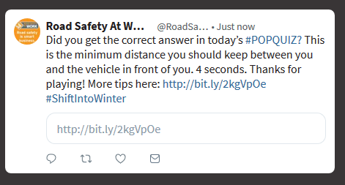

#SIWPopQuiz! Is it too late to put winter tires on your vehicle if you’re still driving in winter weather? #ShiftIntoWinter
If you said “No” to today’s #SIWPopQuiz, you’re absolutely right! Learn more about winter tires here: https://roadsafetyatwork.ca/shift-into-winter/winter-tires/ #ShiftIntoWinter

#SIWPopQuiz! Winter is coming to an end. As a driver, what do you still need to do to ensure your vehicle is safe?

Answer to today’s #SIWPopQuiz! With winter coming to an end, it’s a perfect time to schedule your post-winter vehicle check-up. https://roadsafetyatwork.ca/resource/tool-kit/vehicle-inspections-and-maintenance/ #ShiftIntoWinter

Audience: Employers, supervisors, and employees
Save yourself some time next year and start prepping now for next season. Budget for new winter tires, re-stock emergency kits, and more: https://roadsafetyatwork.ca/resource/tool-kit/winter-driving-safety-planning-tool-kit/#after-winter #ShiftIntoWinter

Wrap up this winter by planning, budgeting and preparing for next year. Visit https://roadsafetyatwork.ca/resource/tool-kit/winter-driving-safety-planning-tool-kit/#after-winter for practical steps to take. #ShiftIntoWinter

With winter winding down for this season, now is a great time to budget, plan, and prepare for next winter. Find tips on how to do that here: https://roadsafetyatwork.ca/resource/tool-kit/winter-driving-safety-planning-tool-kit/#after-winter
#ShiftIntoWinter

Winter is coming to an end, which is actually a perfect time to schedule your post-winter fleet vehicle check-up. Employees who drive their own vehicles for work should do the same. https://roadsafetyatwork.ca/resource/tool-kit/winter-driving-safety-planning-tool-kit/#after-winter
#ShiftIntoWinter

With winter ending soon, now is the time to debrief with your employees. Review info from workplace inspections, MVI investigations and close-call reports. Use our Winter Driving Safety Planning Calendar to help prepare for next year: https://roadsafetyatwork.ca/resource/form/winter-driving-safety-planning-calendar/
#ShiftIntoWinter

Make note of any winter driving hazards you or your employees experienced this season. Re-assess your driving policies and practices. Visit https://roadsafetyatwork.ca/shift-into-winter/employer-and-supervisor-tools/#resources
for info and tools. #ShiftIntoWinter

It’s never too early to develop a winter driving safety plan to keep your employees safe next winter. Take our online course here: https://roadsafetyatwork.ca/resource/online-course/winter-driving-safety-for-employers-and-supervisors/
#ShiftIntoWinter

Long form posts for Instagram, Facebook and LinkedIn (consider appropriate emojis in place of tick marks)

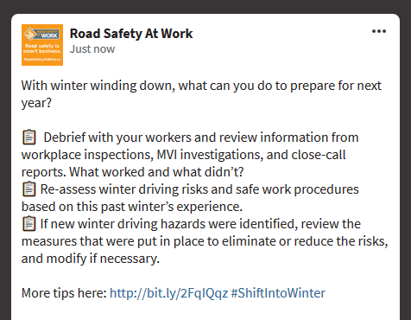

With winter winding down, what can you do to prepare for next year?
- Debrief with your workers and review information from vehicle inspections, MVI investigations, and close-call reports. What worked and what didn’t?
- Re-assess winter driving risks and safe work procedures based on this past winter’s experiences.
- If new winter driving hazards were identified, review the measures that were put in place to eliminate or reduce the risks, and modify if necessary.

More tips here: https://roadsafetyatwork.ca/resource/tool-kit/winter-driving-safety-planning-tool-kit/#after-winter #ShiftIntoWinter

Plan, budget and prepare for next winter! Future you will thank you!
- Identify ways to minimize or eliminate the need for winter driving. Re-assess winter driving risks and safe work procedures based on this past winter’s experience.
- Schedule post-winter maintenance for your vehicles.
- Review your existing winter driving safety policy.
- Plan and budget.

More tips here: https://roadsafetyatwork.ca/resource/tool-kit/winter-driving-safety-planning-tool-kit/#after-winter #ShiftIntoWinter

